15 January 2025

Dr. XY is travelling on behalf of Saving Young Lives to assist with a course training doctors from low resource settings across Africa on dialysis. The workshop is taking place at the International Pediatric Nephrology Association Congress on 19th and 20th February.

He/She is carrying expired medical equipment that is not suitable for use on patients and has no financial value. The equipment is for demonstration use only.

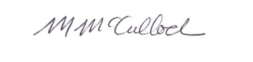

Prof Mignon McCulloch
IPNA Congress Chair
Consultant Paediatric Nephrologist
Red Cross Children’s Hospital

Email: Mignon.mcculloch@uct.ac.za
Phone: 0827804097

