

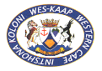

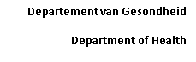**Enquiries: Ward E2 Renal Unit**

**Telephone: (021) 6585053/5153**

**Fax: (021) 6585617**

**Date: 15/1/2024**

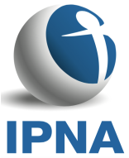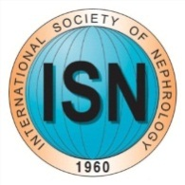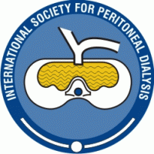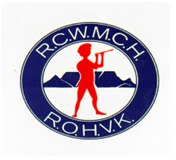

**Saving Young Lives Course**

**Red Cross Children’s Hospital**

**Cape Town**

**Dear Sir/Madam**

**Regarding Dialysis Consumables**

The Doctor or nurse carrying this dialysis stock has had the equipment donated to them for use in their home institution as part of the training they have received during the Saving Young Lives Course.

This has been done under the auspices of the Saving Young Lives Group including IPNA, ISN, EuroPD and ISPD.

Please do not hesitate to contact me if there are any concerns.

Thanks

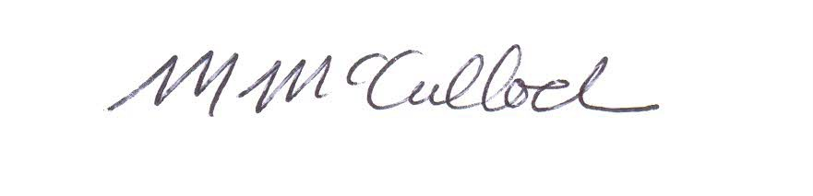

Prof Mignon McCulloch

Consultant Paediatric Nephrologist

Red Cross Children’s Hospital

[Mignon.mcculloch@uct.ac.za](mailto:Mignon.mcculloch@uct.ac.za)

0827804097